Sari-Sari Store Management System v1
Requirements Analysis & System Design
- Problem Statement
What exact problem are we solving?
He operates mostly on estimates, doesn’t know exact numbers of his business.
- User
Who will use it?
My friend.
- Current Process
How does your friend currently track sales, expenses, and inventory?
So, the way his store works is, customers walk one by one and will buy 1 or more item, he served them like a queue so first come first served. More people can be a little bit challenged because you will ask everyone what they want and give it to them after, something like that.
Based on what I observe, he can only track the inventory based on the displayed item, no or less displayed item == low inventory, so that’s also his sales. And I also notice he has a small sheet of paper for customers that has credit to him and need to collect later before closing the store. But he doesn’t list of his sales. He just counts it and I don’t think he saves it.
- Pain Points
What frustrations exist today?
He doesn't know:
- Actual daily profit
- Actual monthly profit
- Best-selling items
- Slow-moving items
- Inventory status
- Cash flow
Because of that, he cannot make data-driven decisions.

- Features
- Record sales
- Record expenses
- Inventory tracking
- Low stock alerts
- Daily report
- Monthly report
- Supplier tracking
- Customer debt tracking ("utang")
- Profit analysis

- MVP Features
- Record sales
- Inventory tracking
- Record Utang
- Daily Sales Summary
- Record expenses
- Manage Products
- Record Restocking
MVP Design Principles
1. Sales must be faster than using a calculator.
2. Frequently sold products should be accessible through large buttons.
3. Common actions should require as few taps as possible.
4. Inventory updates should happen automatically after confirmed sales.
5. Debt recording should not interfere with normal sales workflow.
6. The system should reduce mistakes during busy periods.

- Business Rules
- Every product has a cost price.
- Every product has a selling price.
- A sale can contain multiple products.
- Inventory decreases when a sale occurs.
- Inventory increases when stock is purchased.
- Customer debts above a certain threshold (e.g., ₱100 or more) must be settled before store closing. Smaller debts may remain unpaid until the following day.
- Customers with unresolved overdue debts cannot create new debts
- Some products may be sold using multiple units of measure.
Example:
Marlboro can be sold by Stick or Pack.
- Damaged Products
Supplier Fault
Example:
Received damaged Coke case
Result:
Returned to supplier
Replacement received
Inventory should not permanently decrease.
Owner Fault
Example:
Owner drops bottle
Result:
Store absorbs loss
Inventory decreases.
Potential future report:
Inventory Loss
Customer Fault
Example:
Customer breaks bottle
Result:
Customer pays
Inventory replacement cost is recovered.

- Expired Products
Product nearing expiration
↓
Reduce selling price
↓
Try to sell before expiration

- Entities
- Product
- Product Item
- Sale
- Sale Item
- Supplier
- Customer
• Customer Debt
• Stock
• Purchase
• Operating Expense

- User Stories
- As a store owner, I want to record a sale so that I can track revenue.
- As a store owner, I want to record inventory purchases so that stock levels remain accurate.
- As a store owner, I want to record the utang list so I will not forget to bill anyone and won’t lose profit.
- As a store owner, I want to record purchases from different suppliers to have comparison and plan accordingly.
- As a store owner, I want to see the fastest selling items.
- As a store owner, I want to see the slowest selling items.
- As a store owner, I want to see a dashboard where it can show me my sales, inventory, profit, revenue and will give me business insights for my business to grow.

- Questions / Unknowns
- How should inventory be deducted after a sale?
- How often does the store restock?
- How common is utang?
- Should sales be editable after being saved?
- Can he use this system well while being alone in his store? As being the sole owner and employee. More customers == more sales, but how can he be able to use the system while entertaining the customers at the same time.
- What reports does the owner actually care about?
- How should inventory be tracked for products sold in different units (e.g., cigarettes sold by pack and by stick)?
- Should "Sold By" be stored as text, or is it something important enough to model?

11. Workflow Scenarios
Scenario 1 - Normal Sale
- Customer enters
- Customer selects products
- Owner enters products into system
- System calculates total
- Customer gives money
- System calculates change
- Owner gives change
- Sale is saved
- Inventory decreases
- Dashboard updates

Scenario 2 - Utang
- Customer buys products.
- Customer has no cash.
- Owner records debt.
- Debt appears in utang list.
- Customer pays later.
- Debt is marked paid.
- If debt not paid based on set time, they cannot make utang again.

Scenario 3 - Restocking
- Owner buys inventory.
- Owner records purchase.
- Inventory increases.
- Product cost updates if necessary.

Scenario 4 - End of Day
- Owner opens dashboard.
- Reviews sales.
- Reviews profit.
- Reviews inventory.
- Reviews unpaid utang.

12. Product Categories and Units

Product | Category | Sold By
Marlboro | Cigarette | Stick, Pack
Mighty | Cigarette | Stick, Pack
Red Horse | Liquor | Bottle
Rice | Rice | Kilogram
Coke | Softdrink | Bottle
Egg | Egg | Piece
Candy | Candy | Piece
Mountain Dew | Softdrink | Bottle
Pampers Diaper Piece
Modess Feminine Hygiene Piece
Kopiko 3-in-1 Coffee Sachet
Sardines Canned Goods Can
Tomatoe Vegetable Piece
Onion Vegetable Piece
Ice Tube Ice 1 full small plastic bag

13. Entity Relationships
Sale
- contains many sale items
Sale Item
- belongs to one sale
- references one product
Product
- can come from different Supplier
- can appear in many Sale Items
- can appear in many Product Items
Product Item
- belongs to one Purchase
- references one product
Customer
- can have many Customer Debts
Customer Debt
- belongs to one Customer
-may originate from one Sale
Supplier
- can provide many Product
- can have many Purchase
Purchase
- belongs to one Supplier
- contains many Product Item
Stock
- belongs to one product (Needs further investigation.
May become inventory history tracking in future versions.)
Operating Expense
- has an Amount
- has a Date
- has an Expense Type

14. Business Process Flows
Sales Flow
Customer
↓
Sale
↓
Sale Item
↓
Product
↓
Stock Updated

Utang Flow
Customer
↓
Sale (Most sales do not require customer information.
Customer records are primarily used for utang tracking)
↓
Customer Debt
↓
Payment
↓
Debt Closed

Restocking Flow
Supplier
↓
Purchase
↓
Product Item
↓
Product
↓
Stock Updated

15. Inventory Unit Rules
Rule 1: Cigarettes
Example: Marlboro
Action | Unit
Purchase | Pack
Stock Tracking | Stick
Sale | Stick or pack
Conversion Factor
1 Pack = 20 Sticks
Rule 2: Rice
Action | Unit
Purchase | Sack
Stock Tracking | Kilogram
Sale | Kilogram or Sack
Conversion Factor
1 Sack = 50 Kilograms

Rule 3: Soft Drinks
1 Liter Soft Drinks
Example: Coke 1L
Action | Unit
Purchase | Case
Stock Tracking | Bottle
Sale | Bottle
Conversion Factor
1 Case = 6 Bottles
295ml Soft Drinks
Example: Coke 295ml
Action | Unit
Purchase | Case
Stock Tracking | Bottle
Sale | Bottle
Conversion Factor
1 Case = 24 Bottles

Rule 4: Liquor
Example: Red Horse 1L
Action | Unit
Purchase | Case
Stock Tracking | Bottle
Sale | Bottle
Conversion Factor
1 Case = 6 Bottles

Rule 5: Eggs
Action | Unit
Purchase | Tray
Stock Tracking | Piece
Sale | Piece
Conversion Factor
1 Tray = 30 eggs

Rule 6: Small Consumer Products
Candy
Action | Unit
Purchase | Pack
Stock Tracking | Piece
Sale | Piece

Pampers
Action | Unit
Purchase | Pack
Stock Tracking | Piece
Sale | Piece
Modess
Action | Unit
Purchase | Pack
Stock Tracking | Piece
Sale | Piece
Kopiko 3-in-1
Action | Unit
Purchase | Box/Pack
Stock Tracking | Sachet
Sale | Sachet

Sardines
Action | Unit
Purchase | Case/Box
Stock Tracking | Can
Sale | Can

Rule 7: Inventory Adjustments
Inventory can change for reasons other than sales and purchases.
Supplier-Damaged Products
Damaged products received from supplier may be returned and replaced.
Owner-Damaged Products
Products damaged by the owner are considered inventory loss.
Customer-Damaged Products
Products damaged by customers must be paid for by the customer.
Expiring Products
Products nearing expiration may be sold at a discounted price.

16. System Features
Product Management
- Add Product
- Edit Product
- View Product
- Archive Product

Sales
- Create Sale
- Calculate Total
- Calculate Change
- Update Inventory
Customer Debt
- Create Debt
- Record Payment
- View Outstanding Debt
- View Payment History
Inventory
- Record Purchase
- View Current Stock
- Record Inventory Adjustment
Reports
- Daily Sales
- Current Inventory
- Outstanding Debt
- Operating Expenses
Record Inventory Adjustment
• Add Supplier
• Edit Supplier
• View Supplier

Open Dashboard
Display:
• Today's Sales
• Active Debts
• Low Stock Products
• Today's Expenses

17. Screen List
Sales Screen
Purpose: To quickly record customer purchases and calculate totals.
Information:
- Product
- Quantity
- Unit
- Running Total
- Amount Paid
- Change
- Line Total
Actions:
- Add Product
- Remove Product
- Calculate Total
- Calculate Change
- Confirm Sale
Dashboard
Purpose: to have quick look at today’s sales, current stock, outstanding utang, today’s profit
Information: sales, stock, utang, profit
Actions:
- Open Sales Details
- Open Inventory Screen
- Open Customer Debt Screen
- Open Reports Screen
Customer Debt Screen
Purpose: To track customer debts and payments.
Information: customer name, Outstanding Balance, Due Status
Actions:
- Record New Debt
- Record Payment
- View Debt History
Purchase Screen
Purpose: to record the purchase of product to restock.
Information:
- Supplier
- Product
- Quantity
- Unit
- Cost
Actions:
- Record Purchase
- Update Inventory
- View Purchase History
Inventory Screen
Purpose: To monitor product availability and stock levels.
Information:
- Product
- Current Stock
- Unit
- Low Stock Status
- Last Restocked Date
Actions:
- Search Product
- Adjust Inventory
- View Product Details
Reports Screen
Purpose: View daily sale and profit, and outstanding utang.
Information:
- Daily Sales
- Profit
- Operating Expenses
- Outstanding Debt
Actions:
- Generate Report
- Filter By Date
- Export Report (future)
Supplier Screen
Purpose: View supplier and product availability per supplier
Information:
- Supplier Name
- Contact Information
- Products Supplied
Actions:
- Add Supplier
- Edit Supplier
- View Purchase History

18. MVP Release Plan
Version 1
Manage Products
Create Sale
Calculate Total
Calculate Change
Update Inventory
Goal:
Replace calculator + notebook
Version 2
Customer Debt
Record Payment
Outstanding Debt
Goal:
Replace utang paper
Version 3
Purchases
Suppliers
Restocking
Goal:
Track inventory accurately
Version 4
Expenses
Reports
Dashboard
Goal:
Business insights

19. Detailed User Workflows
Cash Sale Workflow
1. Open Sales Screen
2. Select Product(s)
3. Enter Quantity
4. Review Total
5. Enter Amount Received
6. System Calculates Change
7. Confirm Sale
8. Sale Saved
9. Inventory Updated
Utang Sale Workflow
1.Open Sales Screen
2. Select Product(s)
3. Enter Quantity
4. Review Total
5. Customer cannot pay
6. Select Customer
7. Record Debt
8. Confirm Sale
9. Inventory Updated
Restocking Workflow
1. Open Purchase Screen
2. Select Supplier
3. Add Products
4. Enter Quantities
5. Confirm Purchase
6. Inventory Updated

20. Assumptions and Open Questions
1. Products are managed by the store owner only.
2. There is only one store location.
3. There is only one user of the system.
4. Most sales are cash sales.
5. Customer information is only required for utang.
6. Rice quantities may include decimal values.
7. Product prices may change over time.
Open Questions:
  - Should price history be preserved?
2. Should inventory adjustments require a reason?
3. Should partially paid debts be supported?
4. What is considered low stock for each product?

Scope Decisions
Receipt Printing
- Excluded from system scope.
- Target business is a small neighborhood sari-sari store.
- Transactions are low value and receipts are not part of current operations.
- Digital transaction history serves as the audit trail.

Assumptions and Business Rules
  - Customers can only have one active debt at a time.
2. Partial debt payments are not allowed.
3. Customer records are created only for debt transactions.
4. Receipt printing is excluded from scope.
5. Customer analytics and loyalty programs are excluded.
6. Stock is deducted only after successful sale creation.
7. Debt records are automatically generated from utang sales.

- Project Overview
A simple inventory, sales, purchase, expense, and customer debt (utang) management system designed for small sari-sari stores. The system helps store owners track stock levels, sales transactions, supplier purchases, operating expenses, and customer debts.

- Business Requirements
Cash sales require full payment.
Partial payments are not allowed.
Customers with unpaid debts cannot create new debts.
Debt records are automatically created from utang sales.
Customer records exist only for debt tracking.
Stock decreases after a sale.
Stock increases after a purchase.
Debt payments must be paid in full.
Active debts appear on the dashboard until settled.

- Entity Relationship Diagram (ERD)
The ERD illustrates the relationships between sales, products, purchases, suppliers, customers, debts, and operating expenses.
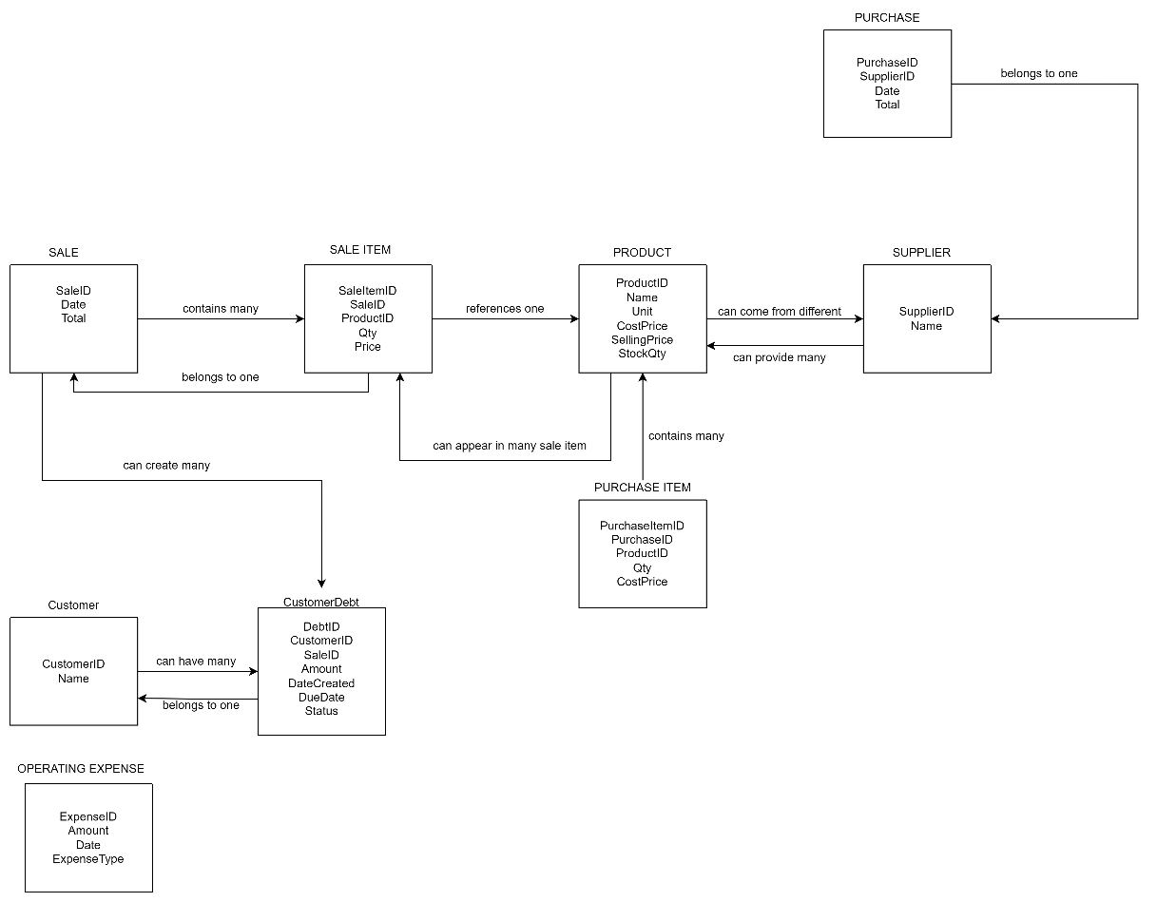

- Data Dictionary
1. SALE
Stores completed cash and utang transactions.
Field Name | Data Type | Key | Description
SaleID | INT | PK | Unique sale transaction ID
Date | DATETIME |  | Date and time of sale
Total | DECIMAL(10,2) |  | Total amount of sale

2. SALE_ITEM
Stores products included in a sale.
Field Name | Data Type | Key | Description
SaleItemID | INT | PK | Unique sale item record
SaleID | INT | FK | References Sale
ProductID | INT | FK | References Product
Qty | INT |  | Quantity sold
Price | DECIMAL(10,2) |  | Selling price at transaction time

3. PRODUCT
Stores inventory information.
Field Name | Data Type | Key | Description
ProductID | INT | PK | Unique product ID
Name | VARCHAR(100) |  | Product name
Unit | VARCHAR(20) |  | Unit of measure (piece, pack, bottle, etc.)
CostPrice | DECIMAL(10,2) |  | Purchase price from supplier
SellingPrice | DECIMAL(10,2) |  | Retail selling price
StockQty | INT |  | Current inventory quantity

4. SUPPLIER
Stores supplier information.
Field Name | Data Type | Key | Description
SupplierID | INT | PK | Unique supplier ID
Name | VARCHAR(100) |  | Supplier name

5. PURCHASE
Stores inventory purchases.
Field Name | Data Type | Key | Description
PurchaseID | INT | PK | Unique purchase transaction
SupplierID | INT | FK | References Supplier
Date | DATETIME |  | Purchase date
Total | DECIMAL(10,2) |  | Total purchase amount

6. PURCHASE_ITEM
Stores products included in a purchase.
Field Name | Data Type | Key | Description
PurchaseItemID | INT | PK | Unique purchase item record
PurchaseID | INT | FK | References Purchase
ProductID | INT | FK | References Product
Qty | INT |  | Quantity purchased
CostPrice | DECIMAL(10,2) |  | Cost price at purchase time

7. CUSTOMER
Stores customer information for utang tracking.
Field Name | Data Type | Key | Description
CustomerID | INT | PK | Unique customer ID
Name | VARCHAR(100) |  | Customer name
Notes
Customers are only created when a customer purchases through utang.
No loyalty program or customer analytics are included.

8. CUSTOMER_DEBT
Stores active customer debts.
Field Name | Data Type | Key | Description
DebtID | INT | PK | Unique debt record
CustomerID | INT | FK | References Customer
SaleID | INT | FK | References Sale
Amount | DECIMAL(10,2) |  | Debt amount
DateCreated | DATETIME |  | Date debt was created
DueDate | DATE |  | Expected payment date
Status | VARCHAR(20) |  | Active or Paid
Business Rules
- Debt is automatically created when an Utang Sale is saved.
- Partial payments are not allowed.
- Customer must fully settle active debt before creating a new debt.
- Only one active debt per customer is allowed.

9. OPERATING_EXPENSE
Stores store operating expenses.
Field Name | Data Type | Key | Description
ExpenseID | INT | PK | Unique expense record
Amount | DECIMAL(10,2) |  | Expense amount
Date | DATETIME |  | Expense date
ExpenseType | VARCHAR(50) |  | Expense category
Examples
- Electricity
- Water
- Internet
- Transportation
- Miscellaneous

Relationship Summary
Parent Table | Child Table | Relationship
Sale | Sale_Item | 1:M
Product | Sale_Item | 1:M
Supplier | Purchase | 1:M
Purchase | Purchase_Item | 1:M
Product | Purchase_Item | 1:M
Customer | Customer_Debt | 1:M
Sale | Customer_Debt | 1:1
Product | Purchase_Item & Sale_Item | 1:M

Database Constraints
CUSTOMER_DEBT
- CustomerID must exist in CUSTOMER.
- SaleID must exist in SALE.
- Status values allowed: Active, Paid.
- Only one Active debt per customer.
SALE_ITEM
- Qty > 0
- Price > 0
PRODUCT
- StockQty >= 0
- CostPrice >= 0
- SellingPrice > CostPrice
PURCHASE_ITEM
- Qty > 0
- CostPrice > 0

- Process Flowcharts
  - Normal Sale Process
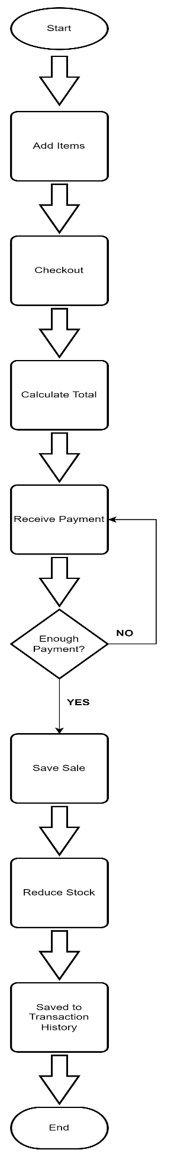
  - Utang Sale Process
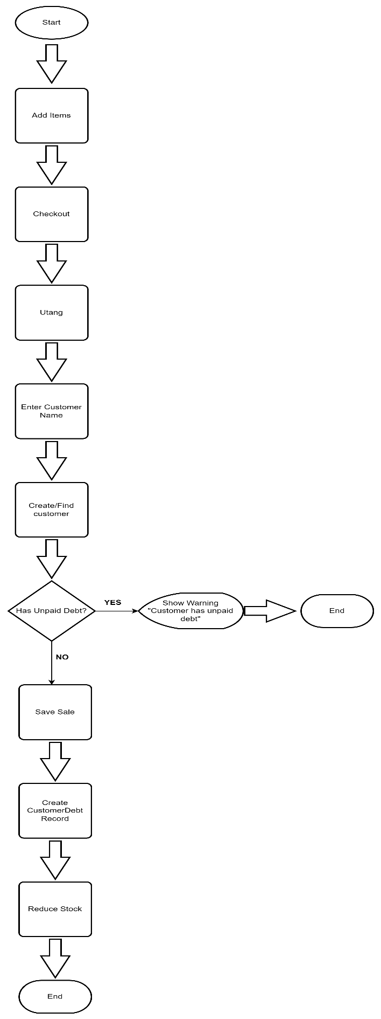

  - Debt Payment Process
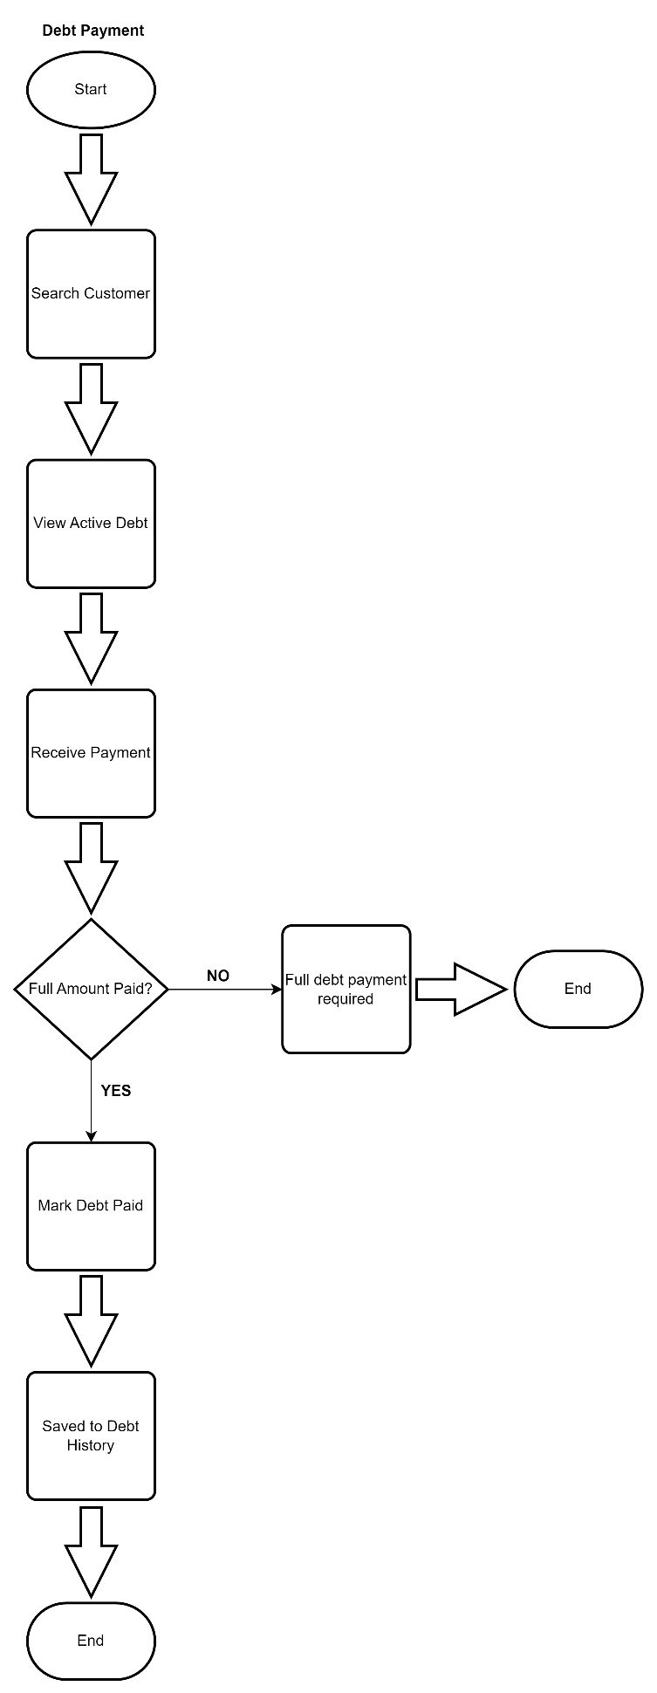
- User Interface Wireframes (Optional but Recommended) - soon
Sketch screens like:
- Dashboard
- Sales Screen
- Utang Screen
- Debt Payment Screen
- Product Management Screen

- SQL Database Design

10. Test Cases
TC-001 Cash Sale Creation
Objective:
Verify that a cash sale can be successfully recorded.
Precondition:
Products exist in inventory.
Steps:
- Add product(s) to cart.
- Proceed to checkout.
- Select Cash Sale.
- Enter payment amount.
- Confirm transaction.
Expected Result:
- Sale record is created.
- Sale items are created.
- Product stock is reduced.
- Transaction completes successfully.

TC-002 Utang Sale Creation
Objective:
Verify that an utang transaction creates a customer debt.
Precondition:
Customer does not have an active unpaid debt.
Steps:
- Add product(s) to cart.
- Proceed to checkout.
- Select Utang Sale.
- Select existing customer or create new customer.
- Confirm transaction.
Expected Result:
- Sale record is created.
- Customer debt record is created automatically.
- Debt status is set to Active.
- Product stock is reduced.

TC-003 Prevent Multiple Active Debts
Objective:
Verify that a customer cannot create a new debt while an active debt exists.
Precondition:
Customer has an active debt.
Steps:
- Attempt to create another utang sale for the same customer.
Expected Result:
- Transaction is rejected.
- Error message is displayed.
- No new debt record is created.

TC-004 Full Debt Payment
Objective:
Verify that debt can only be settled through full payment.
Precondition:
Customer has an active debt.
Steps:
- Select debt payment.
- Pay the full debt amount.
Expected Result:
- Debt status changes to Paid.
- Customer becomes eligible for future utang transactions.

TC-005 Inventory Restocking
Objective:
Verify that inventory increases after a purchase transaction.
Precondition:
Product exists.
Steps:
- Create a purchase transaction.
- Add purchased quantity.
Expected Result:
- Purchase record is created.
- Purchase item record is created.
- Product stock quantity increases.

